**THE COLLEGE SEARCH**

**Constructing a College List**

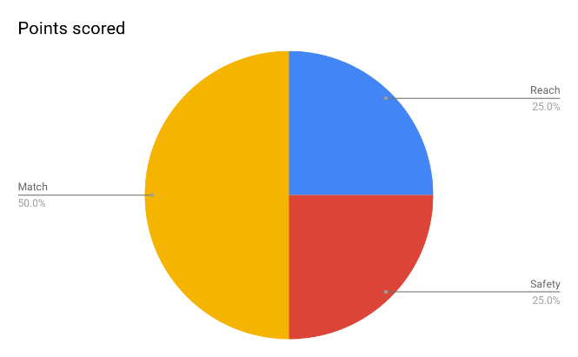

***There’s no magic number, but there is a formula:***

***50% Match -*** A **match** school is a college that you are likely to be admitted and is a good financial fit.

***25% Safety -*** A **safety** school is a college that you will almost certainly be admitted. Do not pick a safety school just to have one on your list.

Instead, find a college that you truly like and can envision yourself attending in the future.

***25% Reach -*** A **reach** school is one that you have a chance of being admitted, but it may be difficult. Colleges with low acceptances rates should always be considered reach schools because even students with perfect grades and test scores might not be accepted.

**Step 1: Understanding Your Needs**

* Websites like **Corsava** and **College Raptor** can help you identify colleges that fit your needs by finding out what’s really important to you about your college experience.
  + **Corsava**: offers a card sort activity that can be done on your phone or computer! The categories go beyond academics and finances.
  + **College Raptor**: register for an account, complete the profile, and then gather a list of 15 schools so you can remove those that aren’t a good fit later

**Step 2: Research Each School (using your College Raptor list)**

* Use Google Earth to research the surroundings and check the distance from home and other important landmarks
* Try You Visit to get a virtual campus tour – www.youvisit.com/collegesearch
* Check admissions data on College Raptor: SAT, ACT, acceptance rate.
* Want to learn more about the vibe? Try looking for “A Day in the Life” videos on YouTube (check the date they were posted)
* If this college looks like it might be a good fit for you, be sure to check out and bookmark the actual admissions page, for the most accurate and timely information.